**Abstract**

I am analyzing different characteristics of the World of Warcraft Classic (WoW Classic) economy to determine if there is predictability in the behavior. The in-game auction house is the benchmark for all tradable item prices in the game, do to it overwhelmingly being the most popular form of trading amongst players. I have written a script to periodically scan the auction house, and extract the data to an AWS server. My primary analysis completed so far includes correlations between craftable items and their respective materials and weekly price trends of items classified as trade goods. My future work on this project is going to be a deeper dive into the behavior of consumable trade goods including logistic regression on the direction of the market.

**1 Introduction**

World of Warcraft Classic (WoW Classic) is a remake of the original Massive Multiplayer Online Role-Playing Game (MMORPG), World of Warcraft, released on November 23, 2004. Within this game, players can complete quests, explore dungeons, and trade with non-player characters (NPCs) and fellow players. One of the major aspects of WoW classic is its complex economy, specifically its auction house. The auction house is a trading hub that allows players to buy and sell items with each other for a price set by the seller. Pricing is competitive and volatile, with players continuously undercutting and buying out each other in an attempt to gain the most profit from their items. Prices can be affected by many factors, such as popularity of the item, relevance to current content, and popular weekly routines of the player-base. Price fluctuations also have an element on randomness to them due to the freedom of the market.

The premise is my project to find any predictability within the in-game stock market that can be harnessed for both short- and long-term investments in items. All of these supports the goal of a deeper understanding of in-game economies. Like the real-world stock market, economies within MMORPG’s contain abstract behavior stemming from human behavior – Some items have very high volatility related to content within the game, and some items have prices that barely change over time.

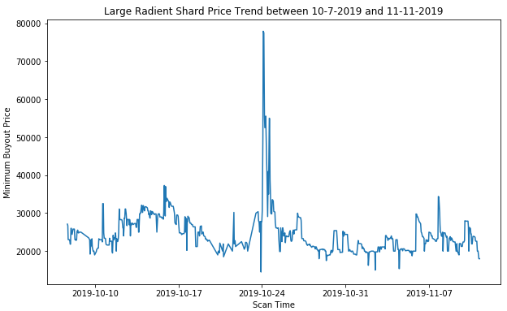

Because there is no public data on the WoW Classic Auction House, I am required to produce my own data set. I have written a script which I have running on a home-made server that perpetually scans the auction house data and uploads it to an AWS database. This allows for an easy form of passive data collection that I can use for my analysis. The script was deployed on 10/7 at 4 pm MST and as of 11/13 the database consists of 749 scans of 5887 items. The next steps in the project is exploratory analysis on certain aspects of the auction house. Such analysis includes correlations between craftable items and their materials, regression price trends, the behavior of high volatility items, and explanations for outliers. So far correlation analysis had been done between craftable Best-in-Slot (BiS) items and their respective materials, and I am beginning to explore weekly price trends for certain items. Lastly, I plan on doing logistic regression to predict the future direction of the prices on the auction house.

**2 Checkpoint**

**Data Collection**

I have deployed the script to extract the auction house data from WoW Classic’s game files. The script is running on an old computer perpetually scanning the most recent auction house data and looking for updates (Figure 2). To access the game data, I am using a licensed addon called TradeSkillMaster (TSM) which scans the auction house periodically. Because WoW Classic does not have any publicly accessible API, TSM relies on players in the game to manually scan the auction house using the in-game app. This data is then uploaded to an external program which syncs will all other players using the app. Because many players use this app, it updates rather frequently. The updated data is stored in the game files, in a file called AppData.lua. Every time AppData.lua updates, my script parses and cleans the data and pushes it to an AWS postgres database.

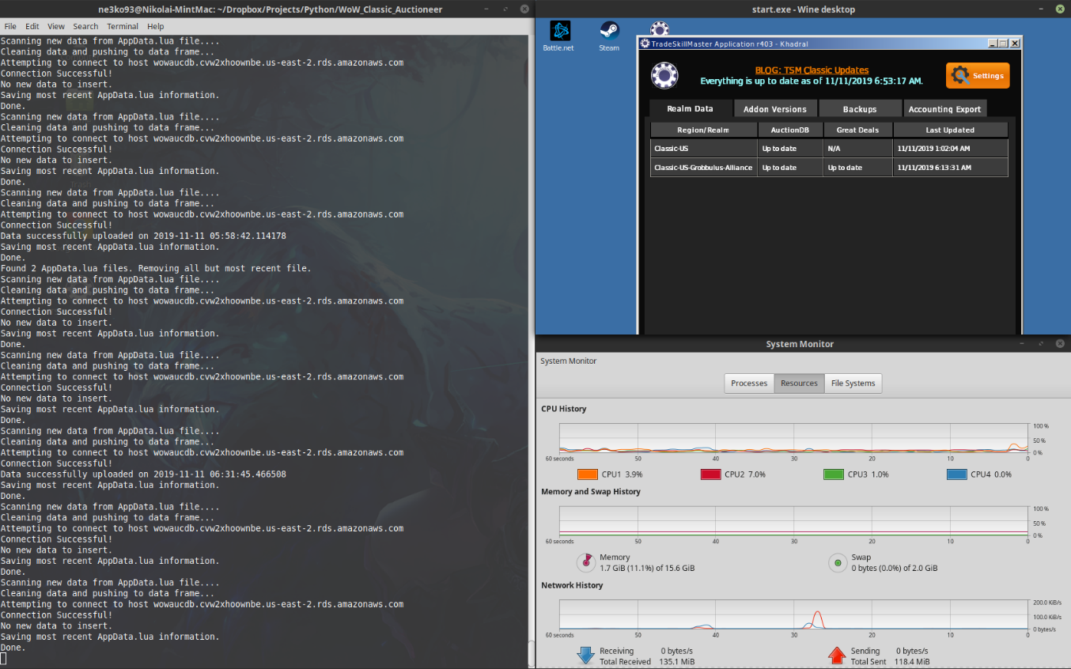

**Correlations**

So far I have done correlation analysis on the craftable Best-in-Slot (BiS) gear and their respective materials. I have looked at Green Lens, Devilsaur Gauntlets, and Devilsaur leggings. Unfortunately, for the most part the materials had little-to-no correlation with the craftable items. My hypothesis on this is that many materials are used to craft many items, leading to quite a bit of disassociation with specific craftables. However, I did find an interesting correlation between Devilsaur Gauntlets and Devilsaur Leggings – They have a strong correlation of 0.52. I am planning on doing future analysis to see if there are any other factors playing into the correlation of these two items.

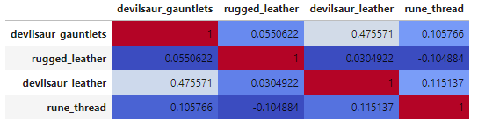

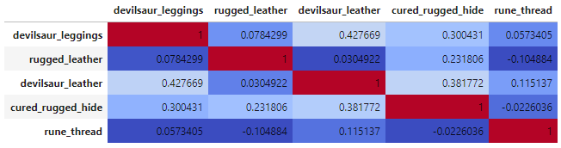

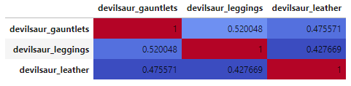

**Weekly Trend – Large Radiant Shard**

The next thing I looked at was weekly trends of the item Large Radiant Shard. The reason I chose this item is because I have been watching quite a bit over the course of a couple weeks and hypothesised that there was in-fact a trend. It also had a random spike in price, where the price increased to almost 4x its value over the course of two days. From a basic five-number-summary, and a scatterplot of the data over the course I have not seen anything that stands out. There looks to be a slight increase price over Wednesday and Thursday and a decrease on Fridays, however not by much.

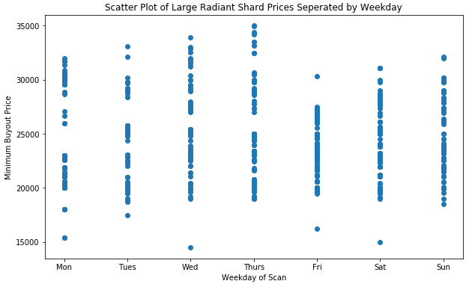

**3 Further Work**

**Future Exploratory Analysis**

Through the analysis I have done so far, I have not found any information that particularly stands out, and have come to the conclusion that I have been looking at the wrong types of items for my goal. Majority of the items I have looked at are one-time buys, such as armor and weapons. This leads to two problems: These items have a very low buy percentage relative to other types of items, and as a result there is very low volatility relative to other items. Enchanting materials perform slightly better. However, enchantments on gear are permanent, so a player generally only gets a particular enchantment once per piece of wearable items.

My next approach is looking at specific consumable items, or items that a player can use only once. One item in particular is the Greater Fire Protection Potion. One of the major aspects of WoW Classic is the raiding content – A large group of 25 to 40 players get together to infiltrate a massive instance usually resulting in defeating a major antagonist. In the current raiding content, the three major raids are all themed around fire. In order to increase survivability, players need to maximize their fire resistance in every possible way they can. The final boss of The Molten Core, Ragnaros, is virtually impossible to beat without very high fire resistance. As a result, in theory, the rate in which Greater Fire Protection Potion is posted correlates well with the raiding schedule – groups tend to raid more between Tuesday and Thursdays due to the server reset being every Tuesday. Another set of consumables to look at are flasks, such as Flask of the Titans and Flask of Distilled Wisdom. Flasks are extremely powerful potions crafted by players with high Alchemy skills, which are essential in high level content. What makes flasks so important, is their effects last through death. So, if a player consumes Flask of the Titans, their health is guaranteed to increase by 1200 for an hour.

**Logistic Regression on Price Changes**

Finally, I am planning on using Logistic Regression to predict the direction of the market based on its current values. I am debating between two types of data for this prediction: Daily summaries of the data, or point by point scans of the data. The daily summaries would be structured similarly to a stock market summary. The data set would consist of the opening price (first scan of the day), closing price (last scan of the day), high, low, and volume. The volume is going to be the most difficult of the attributes to figure out, as there is no way of tracking if specific postings are sold. A couple of plans for dealing with this are using the mean number of auctions for the day or the maximum number of auctions for the day. Another shortcoming of this method is that we only have a few instances to work with – So far there is only 39 days’ worth of data. The second method would be taking the raw data and predicting the price change between each scan. The pros of this are that we have much more data to work with (800+ instances rather than 39 instances), and we can more accurately use the number of auctions with each scan. One of the weaknesses to this method is that there is the risk of a much higher level of randomness when predicting price changes on this level, as experienced with predicting the stock market. I am going to experiment with both methods to see which performs better.